Feel free to connect with me on LinkedIn—I’d be happy to connect with you.
Project Coversheet
Full Name | Ivelina Angelova
Project Title (Example – Week1, Week2, Week3, Week 4) | Week 4 - Project: Business Intelligence Dashboard for TechHub Retail 27/11/2025
Instructions:
Students must download this cover sheet, use it as the first page of their project, and then save the entire document as a PDF before submission.
Project Guidelines and Rules
1. Formatting and Submission
- Format: Use a readable font (e.g., Arial/Times New Roman), size 12, 1.5 line spacing.
- Title: Include Week and Title (Example - Week 1: Travel Ease Case Study.)
- File Format: Submit as PDF or Word file
- Page Limit: 4–5 pages, including the title and references.
2. Answer Requirements
- Word Count: Each answer should be within 100–150 words; Maximum 800–1,200 words.
- Clarity: Write concise, structured answers with key points.
- Tone: Use formal, professional language.
3. Content Rules
- Answer all questions thoroughly, referencing case study concepts.
- Use examples where possible (e.g., risk assessment techniques).
- Break complex answers into bullet points or lists.
4. Plagiarism Policy
- Submit original work; no copy-pasting.
- Cite external material in a consistent format (e.g., APA, MLA).
5. Evaluation Criteria
- Understanding: Clear grasp of business analysis principles.
- Application: Effective use of concepts like cost-benefit analysis and Agile/Waterfall.
- Clarity: Logical, well-structured responses.
- Creativity: Innovative problem-solving and examples.
- Completeness: Answer all questions within the word limit.
6. Deadlines and Late Submissions
- Deadline: Submit on time; trainees who fail to submit the project will miss the “Certificate of Excellence”
7. Additional Resources
- Refer to lecture notes and recommended readings.
- Contact the instructor or peers for clarifications before the deadline.

YOU CAN START YOUR PROJECT FROM HERE

TechHub Retail – Sales & Customer Insights Dashboard Report (2023–2024)

1. Introduction
TechHub Retail is a fast-growing online electronics retailer operating across the UK. With the company expanding quickly over the past 18 months, leadership needed a clearer understanding of customer behaviour, sales performance, and product profitability to support planning for 2025. This project brings together sales, customer, and product data into interactive Tableau dashboards. The goal was to turn raw data into insights that TechHub leaders can use to make informed decisions. Two dashboards were created:
- An Executive KPI Dashboard for quick high-level performance checks
- A Sales & Customer Insights Dashboard for deeper exploration of trends, customer profiles, product performance, and supplier impact
Together, these dashboards help the business understand what is working well, where opportunities exist, and which actions could support growth in the next year.

2. Multi-Dataset Integration Summary

2.1 Connecting the Datasets
Three datasets were used:
- customers_clean.csv
- sales_clean.csv
- products_clean.csv
These were connected in Tableau using:
- customer_id to link sales with customers
- product_id to link sales with products
This created a clean relational structure where each sale could be enriched with customer demographics and product details.
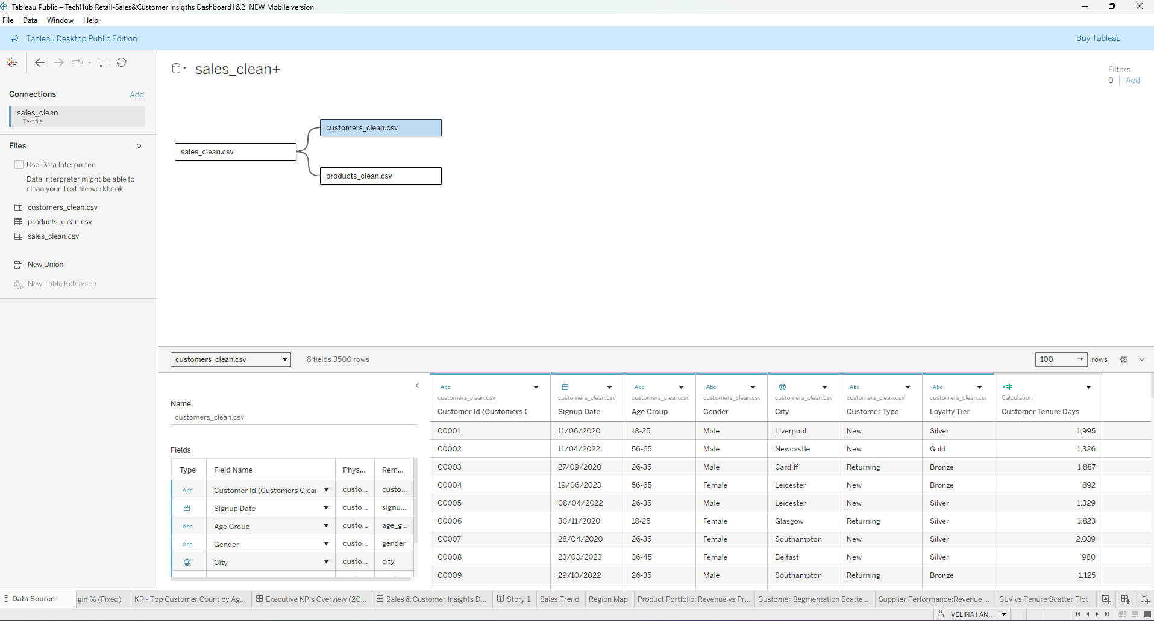
Figure 1Data Source Relationships View

2.2 Data Preparation & Cleaning
Several preparation steps ensured the data was ready for analysis:
Aspect | Details
Date Fields | Order Date, Signup Date, Launch Date converted to Tableau date formats, organised into hierarchies (Year → Month → Week → Day)
Missing Values | Minor missing demographic values in customer dataset, none affected calculations; No missing product_id or customer_id in sales dataset, all rows usable
Data Type Validation | Revenue, Cost Price, Quantity, Profit corrected to numerical types; customer type, age group, region, product category assigned as dimensions

2.3 Calculated Fields Created
To support the dashboards, several calculated fields were created:
Field | Logic/Formula | Description
Profit Amount (Corrected) | [Revenue] - ([Cost Price] * [Quantity]) | Replaced the inconsistent profit column in the raw dataset
Profit Margin % (Corrected) | [Profit Amount] / [Revenue]
Customer Tenure Days | DATEDIFF('day', [Signup Date], TODAY())
Customer Lifetime Value (CLV) | SUM([Revenue])
Product Age Days | DATEDIFF('day', [Launch Date], [Order Date])
Total Revenue | KPI logic field | Supported accurate and reliable KPI calculations
Total Customers | KPI logic field | Supported accurate and reliable KPI calculations
Average Order Value | KPI logic field | Supported accurate and reliable KPI calculations
Top Customer Segment | KPI logic field | Supported accurate and reliable KPI calculations
Customer Acquisition Rate | KPI logic field | Supported accurate and reliable KPI calculations

3. Dashboard Design Summary

3.1 Executive KPI Dashboard
The first dashboard presents TechHub’s most important performance metrics in a simple, visual layout. It includes:
- Total Revenue
- Total Customers
- Average Order Value
- Profit Margin %
- Customer Acquisition Rate
- Top Customer Segment (Age Group)
The KPIs were designed as clean individual tiles with consistent fonts, colours, and spacing to provide an instant overview of business performance.
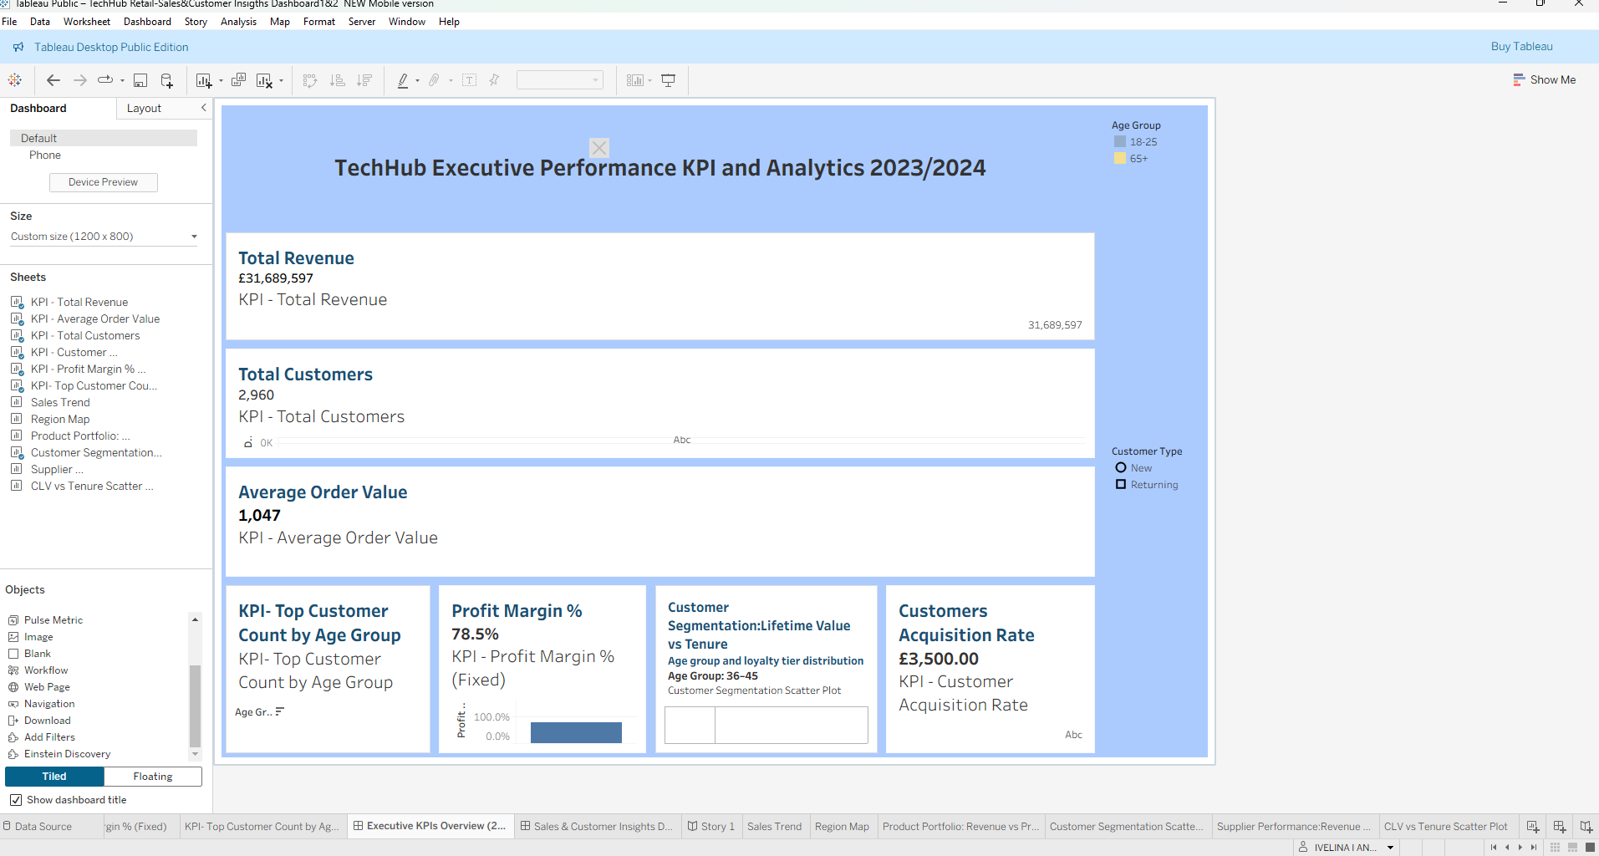
Figure 2Executive KPI Dashboard1

3.2 Sales & Customer Insights Dashboard
The second dashboard goes deeper and includes six main visualisations with interactive filters:

1. Revenue Distribution Across Time
Shows how revenue changes weekly and highlights seasonal peaks.

2. Sales Trend (Dual Axis: Revenue vs Profit)
Compares revenue and profit changes across time to identify profitable periods.

3. Regional Performance Map (UK)
Displays revenue contribution across regions and helps identify strong or emerging locations.

4. Customer Segmentation Scatter Plot
Explores customer behaviour by age group, loyalty tier, and value.

5. CLV vs Tenure Scatter Plot
Shows how customer lifetime value grows with retention and helps identify high-value customer clusters.

6. Product Portfolio Treemap
Highlights the most profitable and most frequently purchased product categories.

7. Supplier Performance Chart
Shows which suppliers contribute the most revenue and product volume.

Interactive Filters:
- Date Range
- Age Group
- Customer Type
- Product Category
- Supplier
- Loyalty Tier
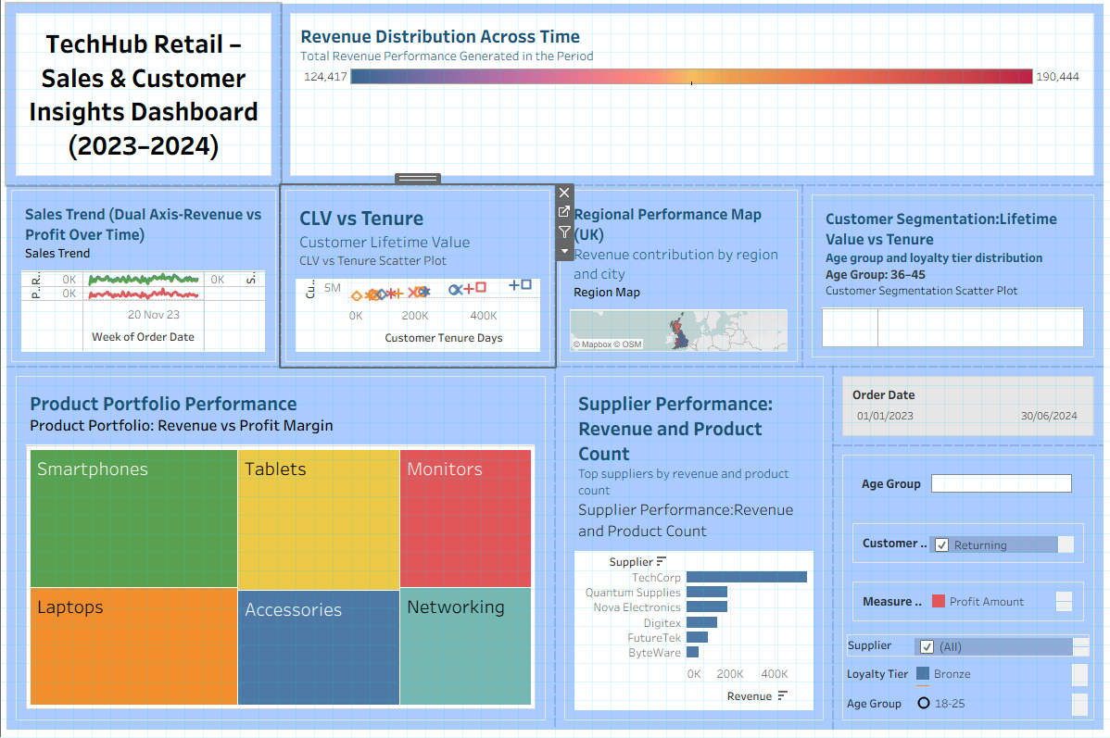
Figure 3Sales & Customer Insights Dashboard 2

4. Key Insights & Findings

4.1 Revenue & Profitability Insights
- TechHub Retail generated £31.6M during the period analysed. Revenue patterns remain stable, with expected spikes around seasonal promotions (especially Q4).
- The average order value (AOV) of £1,047 suggests that customers consistently purchase mid- to high-priced electronics.
- A notable finding is the profit margin of 78.5%, which indicates strong pricing power and well-managed cost structures across the top product categories.

4.2 Customer Behaviour Insights
The 36–45 age group is the highest-spending customer segment, significantly contributing to total revenue. This group shows strong brand engagement and purchase frequency.Returning customers demonstrate higher lifetime value and longer tenure. This highlights loyalty as a key business driver and suggests that investing in retention could have a strong return.

4.3 Regional Insights
The UK region map shows two standout areas:

• London – highest concentration of revenue

• Manchester – strong secondary performance
These are TechHub’s strongest geographic markets. Other regions contribute modestly, indicating opportunities for regional expansion and targeted marketing campaigns.

4.4 Product Portfolio Findings
The Treemap analysis shows:

✔ Smartphones

✔ Tablets
These categories generate the highest revenue and profit contribution. They are followed by Laptops and Monitors.
Underperforming categories include:
- Networking
- Accessories
These may benefit from bundling, discounting, or product refresh strategies.

4.5 Supplier Performance Findings
Supplier analysis shows that TechCorp and Quantum Supplies contribute the largest portion of product revenue. A smaller group of suppliers provides minimal contribution, suggesting potential inefficiency or low customer demand for certain product ranges.

5. Business Questions Answered

1. Which product categories and suppliers offer the best profit margins for 2025 focus?
The analysis shows that Smartphones and Tablets deliver the highest margins and consistent revenue contribution, making them the strongest categories for strategic investment in 2025. Supplier analysis reveals that performance is heavily concentrated among a small group of top suppliers, primarily TechCorp and Quantum Supplies. This dependency increases vulnerability to supply disruptions and limits negotiation leverage. To mitigate this, TechHub should strengthen relationships with leading suppliers while concurrently evaluating secondary suppliers for margin improvement opportunities.

2. How do customer demographics impact purchasing behaviour?
Customer behaviour is strongly influenced by age and loyalty tier. The 36–45 age segment demonstrates the highest purchasing frequency and the strongest lifetime value, suggesting greater disposable income and stronger brand engagement. In contrast, younger age groups (18–25) display lower overall spend but show potential for long-term value if nurtured early. Loyalty tier strongly correlates with CLV: customers in Gold and Silver tiers consistently outperform Bronze-tier customers. These patterns indicate the need for targeted and differentiated engagement strategies by demographic and loyalty tier.

3. What seasonal patterns exist across product categories and regions?
Clear seasonal peaks were identified, particularly in November and December, aligning with Black Friday, Cyber Monday, and holiday sales periods. These surges occur across Smartphones, Tablets, and Laptop categories. Regionally, the largest seasonal gains are concentrated in London and Manchester, while smaller regions show more modest seasonal variation. This suggests that national-level promotions may disproportionately benefit high-population regions, and regionalised campaigns could help balance performance across the UK.

4. Which customer acquisition channels deliver the highest-value customers?
Organic and Referral channels generate customers with significantly higher CLV and longer tenure, indicating that these channels attract more committed and valuable customers. Paid channels produce higher acquisition volume but lower long-term value, suggesting a misalignment between marketing spend and business outcomes. The data implies that TechHub should shift investment toward cost-efficient, value-driven acquisition channels, rather than volume-driven ones.

5. How does product age correlate with sales performance?
A clear lifecycle pattern is evident: newly launched products generate strong early revenue spikes but stabilise after approximately three months. Older products still contribute to revenue but at a reduced pace. This trend confirms the importance of regular product refreshes in the electronics sector, and suggests that ageing inventory may require targeted discounting or bundling to maintain competitiveness.

6. What strategic recommendations emerge from the integrated analysis?
The integrated view reveals opportunities to optimise inventory, refine regional focus, target high-value segments, and strengthen supplier leverage. Key recommendations include enhancing retention strategies for high-value segments, prioritising top-margin products, rebalancing acquisition spending, and improving supply chain efficiency.

6. Strategic Recommendations for 2025

1. Prioritise investment in high-margin product categories
Smartphones and Tablets show strong and consistent demand alongside high margins. TechHub should allocate a greater share of marketing and inventory budgets to these categories, while implementing promotional strategies (bundles, warranty extensions) to increase average order value.

2. Strengthen supplier diversification and renegotiation strategies
A significant portion of TechHub’s revenue is dependent on a small number of suppliers. This concentration increases risk around supply chain stability and pricing power. TechHub should renegotiate volume-based agreements with high-performing suppliers while also exploring strategic partnerships with alternative suppliers to reduce dependency.

3. Enhance customer retention programmes for high-value segments
The 36–45 segment demonstrates the highest lifetime value. Implementing personalised loyalty schemes, early-access sales, and premium customer service features would help maintain and grow this segment. Automating onboarding for new customers could also improve long-term retention.

4. Optimise marketing allocation towards profitable acquisition channels
Paid marketing contributes lower lifetime value customers compared to Organic and Referral channels. TechHub should reduce budget in low-margin acquisition channels and reinvest in referral programmes, SEO optimisation, and repeat-customer incentives.

5. Expand regional marketing initiatives outside major cities
London and Manchester are already performing well, but other regions show underutilised potential. TechHub should implement targeted campaigns in mid-tier cities and optimise delivery logistics to enhance customer experience and reduce friction.

6. Improve lifecycle management for ageing products
Older electronics lose relevance quickly. TechHub should implement a structured lifecycle pricing strategy, including clearance discounts, bundling, and accessory upsells, to reduce slow-moving inventory and protect margins.
7. Critical Reflection
The dashboards successfully bring together multiple aspects of TechHub’s operations-sales patterns, customer behaviour, product performance, and supplier efficiency into a digestible, interactive format. The integration of multiple datasets allows for a more holistic understanding of the business compared to isolated departmental reporting.However, the process highlighted several challenges. One issue was ensuring data consistency across datasets, especially regarding profit fields that required correction. Establishing reliable relationships between datasets also required careful validation of product and customer IDs. Additionally, transforming the data into meaningful KPIs required multiple iterations of calculated fields, highlighting the importance of accuracy in data modelling. From a design perspective, the dashboards are effective for high-level decision-making, but there is room for enhancement. Predictive features such as churn forecasting or seasonal revenue projection would significantly strengthen strategic planning. The dashboards also rely on filters for exploration; however, executive users may require additional guided insights such as automated narratives or priority alerts. Finally, although the dashboards are mobile-friendly, further refinement could enhance the mobile experience, as some visualisations are easier to interpret on desktop. Overall, the analysis demonstrates the value of BI dashboards as decision-support tools, while also highlighting opportunities for future improvement.

8. Data Issues or Risks
Issue | Description | Potential Impact | Recommendation
Data Completeness Issues | Core identifiers (product_id, customer_id) complete; some demographic fields missing values | May introduce bias in customer behaviour or segmentation | Monitor and address missing demographic data
Inconsistent Profit Calculations | Profit field incorrect and had to be recalculated | Concerns about accuracy of data pipeline | Stronger internal data validation processes needed
Limited Time Range | Dataset covers ~18 months | Limits long-term trend analysis, reduces seasonality detection reliability | Use multi-year data for future forecasting models
Supplier and Product Imbalance | Few suppliers dominate; some product categories have limited sales data | Weak insights for lower-volume suppliers, distorts margin analysis | Consider statistical adjustments for imbalance
Potential Over-Reliance on Aggregated Data | Metrics like lifetime value, tenure rely on aggregated revenue | May hide individual customer variability, reduce segmentation accuracy | Analyze individual-level data where possible
Risk of Misinterpretation | Dashboards may be misinterpreted by executive users without data literacy training | Correlations mistaken for causations, misaligned decisions | Clear annotation and report explanations needed

